Specifications Document for the

PatheTech System
Author(s)
Paul Giampaolo, Mike Delaney, Mark Smorul
Kurt Legerlotz, Matt Bohn, Matt Hensinger
Mike Niesslein
PatheTech Software Development Group
Affiliation
1984 Orwell Lane
2/15/04
Version 1.0

1. Introduction
- 1.1 Purpose of this document
This document details the requirements for the customer/mechanic interaction system for PatheTech Industries.

- 1.2 Scope of this document
Requirements covered in this document include the areas of the system involving interaction between users and automated server actions. System users are the customers whose vehicles are being serviced and mechanics doing the servicing. The system also receives reports from computer systems on board vehicles.
Section 2 will diagram the system data flow and detail overall system structure. Section 3 includes requirements. Interfaces are detailed in Section 4 and use cases are in section 5.
- 1.3 Overview
PatheTech services many vehicles and in order to stay competitive would like to institute a method by which clients can remotely access their vehicle status and provide a new line of communication between clients and mechanics performing the maintenance. This system also would include capabilities for the vehicles on board computer systems to remotely provide diagnostic information allowing mechanics to preemptively contact client regarding vehicle maintenance.

- 1.4 Business Context
PatheTech is devoted to providing a long term solution to increase the ease of client/mechanic relations. This will streamline the maintenance process allowing better use of mechanic time and provide faster service to clients.
2. General Description
- 2.1 Product Functions
The primary functionality of this system will be to provide an online method of communication between clients and mechanics. The system will provide status, allow for updating status, keeping track of old maintenance, and allow confirmation of repair requests. The system will also process data from vehicles on board computer systems.
- 2.2 Similar System Information
The system has a web based front end for access to the system.
- 2.3 User Characteristics
Users are expected to have basic understanding web browsers, which will be the primary interface into the system for clients. Mechanics will be trained on site.
- 2.4 User Problem Statement
Currently all communication between clients and mechanics must occur via telephone or in person. This system will allow for a more convenient alternative to these methods.
- 2.5 User Objectives
The clients will use the system to schedule maintenance, check vehicle status, and confirm maintenance requests. Mechanics will use the system to keep the vehicle status up to date and receive feedback from clients relating to maintenance. The data flow diagram shows an overview of the system.
- I’m not sure what the above diagram represents in terms of data flow. I’m not sure what’s a process, what’s an entity, and where the data stores are.

- 2.6 General Constraints
The system will use a web based application as a front end to the database interactions.

3. Functional Requirements
- Create account for new users.
  - Description
When new users are added to the system, an account will be created with information containing the users' vehicles, contact information, and login information.
  - Criticality
This requirement is very fundamental to the operation of the system. Without this functionality, users would not be able to access the system.
  - Technical issues
The database must be able to add all user contact and login information at this point in the system.
  - Cost and schedule
There are no specific cost issues with this requirement.
  - Risks
The database must be created so that user information is stored correctly, and is easily found. Login information must be able to be verified correctly for this requirement as well.
  - Dependencies with other requirements
Users can modify any of the information on their account anytime after their account is created. This is shown in the modify account feature that is shown as requirement number 2.

- Modify accounts for existing users.
  - Description
Anytime after an account is created, the user can edit any of their information. Users can add and remove cars from their account with this functionality as well.
  - Criticality
This requirement is very fundamental to the operation of the system. It is absolutely necessary to at least be able to add and remove cars from a user's account. Also if a user moves, they will need to be able to change their contact information.
  - Technical issues
The database must be able to edit all user contact and login information at this point in the system. It must also be able to associate cars with the users' accounts.
  - Cost and schedule
There are no specific cost issues with this requirement.
  - Risks
The database must be created so that user information can be edited correctly, and is easily found. The database must also be implemented so that cars can be added and removed from each account.
  - Dependencies with other requirements
This functionality can only be reached after creating a new account which is shown in requirement number 1.

- Schedule maintenance
  - Description
The user can submit a request to schedule maintenance on any of the cars that currently exist on their account. As part of this feature, the user can input the date, along with a description of what maintenance needs to be done on their car.
  - Criticality
This requirement is very fundamental to the operation of the system. This is one of the main purposes of the system. It is necessary that the user be able to schedule maintenance to be done on their car.
  - Technical issues
The system must provide a place for the user to be able to enter the date and maintenance they need. This information then needs to be sent to the mechanic so the maintenance can be scheduled.
  - Cost and schedule
There are no specific cost issues with this requirement.
  - Risks
The system must be implemented so that the information is not lost or changed in transitions from the user to the mechanic.
  - Dependencies with other requirements
There are no dependencies between this and other requirements.

- Obtain status of maintenance being performed on vehicle
  - Description
At any time during the maintenance of the vehicle, the user can log on and view the status of the maintenance on the vehicle. This will also include an updated estimate of when repairs will be completed on the vehicle.
  - Criticality
This requirement is somewhat fundamental to the operation of the system. It is beneficial that the user be able to check the status of the maintenance being performed on their car, but it is not an absolute necessity.
  - Technical issues
The server must provide a place for the mechanic to be able to enter the maintenance that they have performed and estimated dates of completion. This information then needs to be sent to the users so they remain updated throughout the process.
  - Cost and schedule
There are no specific cost issues with this requirement.
  - Risks
The system must be implemented so that the information is not lost or changed in transitions from the mechanic to the user.
  - Dependencies with other requirements
This requirement is related to the feature that allows the mechanic to be able to enter all of this information into the system. That feature is listed as requirement number 6.

- Track previous maintenance performed on each vehicle
  - Description
Mechanics can view a list of previous maintenance that has been performed on any vehicle that is in the database. The user can view the previous maintenance that has been performed on any vehicle on their account.
  - Criticality
This requirement is semi fundamental to the operation of the system. It is a useful tool for either users or mechanics to be able to know what have been common problems for the car, however this feature is not necessary for the functionality of the system.
  - Technical issues
The information about all of the maintenance that has been performed on any car must be stored and must be able to be found when it is searched for. This information must then be displayed in a list so that users and mechanics can view it.
  - Cost and schedule
There are no specific cost issues with this requirement.
  - Risks
The database must be implemented so that the information is not lost after maintenance is performed on the vehicle. This information must be stored so that it can be found at a later time.
  - Dependencies with other requirements
There are no dependencies between this and other requirements.

- Mechanics can post information on the maintenance that is being performed
  - Description
Mechanics can post up to date information for the current vehicle maintenance. This information will include what repairs have been made to the vehicle, along with the amount of time that has been spent on it, and the current estimate.
  - Criticality
This requirement is somewhat fundamental to the operation of the system. It is very beneficial that the mechanic be able to enter the status of the maintenance being performed on their car, but it is not an absolute necessity.
  - Technical issues
The server must provide a place for the mechanic to be able to enter the maintenance that they have performed, price estimates, and estimated dates of completion. This information then needs to be sent to the users so they remain updated throughout the process.
  - Cost and schedule
There are no specific cost issues with this requirement.
  - Risks
The system must be implemented so that the information is not lost or changed in transitions from the mechanic to the user.
  - Dependencies with other requirements
This requirement is related to the feature that allows the customer to be able to check all of this information. That feature is listed as requirement number 4.

- Email confirmation for major repairs
  - Description
Mechanics can email the customer when confirmation is needed for major repairs. This will include the description of what needs to be done along with the cost. The customer will then be able to log on and post a confirmation, giving the mechanic permission to proceed with the necessary repairs.
  - Criticality
This requirement is semi fundamental to the operation of the system. It will make confirmation easy if the customer is not at home but can be somewhere that they can check their email. Without this feature, confirmation will just be done by phone like it is now.
  - Technical issues
This is just an email that will be sent from the mechanic to the customer and then the confirmation that will be posted by the customer.
  - Cost and schedule
There are no specific cost issues with this requirement.
  - Risks
The system must be implemented so that the email is able to be sent from the mechanic to the customer. Also, the customer must be able to post whether they approve the maintenance or not.
  - Dependencies with other requirements
There are no dependencies between this and other requirements.

- Email notification of completed repairs
  - Description
The system will automatically send an email to the customer whenever the mechanic posts that the maintenance that was being performed on the vehicle is complete.
  - Criticality
This requirement is not really fundamental to the operation of the system. It will simply let customers know right away when their repairs have been completed.
  - Technical issues
This is just an email that will be sent to the customer. The system will have to be able to automatically send a generic message to the customer when the mechanic posts that the repairs are complete.
  - Cost and schedule
There are no specific cost issues with this requirement.
  - Risks
The system must be implemented so that the email is able to be sent to the customer. The system will have to know to do this automatically when the repairs are done. If it does not do this automatically, customers will have to log on to the system all the time to see when their vehicle is done.
  - Dependencies with other requirements
There are no dependencies between this and other requirements.

- Email notification for routine maintenance
  - Description
Once a customer is in the database, the system will send out email notifications when routine maintenance needs to be scheduled, or when a product recall has been posted. This will remind customers when it is time to do things like oil changes, tire rotations, and inspections.
  - Criticality
This requirement is not really fundamental to the operation of the system. It is a very nice reminder however whenever a car needs some routine maintenance, or checkups.
  - Technical issues
This is just an email that will be sent to the customer. The system will be able to send these emails automatically whenever a car that is in the database needs maintenance. It will also send these emails out to all cars that are affected when a mechanic posts a recall.
  - Cost and schedule
There are no specific cost issues with this requirement.
  - Risks
The system must be implemented so that the email is able to be sent to the customer. The system will have to know to do this automatically when the repairs are needed. It will also have to be able to search the database for all of the cars that are affected by any recalls that are posted and then send the customers that own those cars emails as well.
  - Dependencies with other requirements
There are no dependencies between this and other requirements.

- Receive error messages from onboard computer
  - Description
An onboard computer system on the car will send error messages to the server whenever there is a problem with the car. Examples of this would be engine overheating, brake failure, oil overheating, low oil, low fuel pressure, or spark plug failure. This will be simulated by an external program.
  - Criticality
This requirement is independent of the core system features, and is not necessary for the rest of the system to function properly.
  - Technical issues
This system will be emulated by several programs running on a workstation that will connect to the server and send an error message based on random numbers for frequency and the error indicated.
  - Cost and schedule
There are no specific cost issues with this requirement.
  - Risks
The clients must be able to connect to the server, and two may attempt to connect at the same time.
  - Dependencies with other requirements
There are no dependencies between this and other requirements.

4. Interface Requirements
- 4.1 User Interfaces
The web interface serves as the primary channel for user controlled communication. The automobile owners and mechanics can use the web interface for various forms of indirect communication. Updates can be displayed on the pages and email can be sent as well. A separate socket based interface will be used for allowing automobiles implementing OnStar to connect directly to the server. This interface will allow the mechanic to receive error reports directly from the car.
  - 4.1.1 GUI
The graphical user interface will be split into two separate parts, one for the automobile owner and one for the mechanic. The mechanic interface will be described first
- Mechanic Pages
1. Login Page
This is the first page the mechanics will need to enter. This page will allow the mechanic to log in to the website.
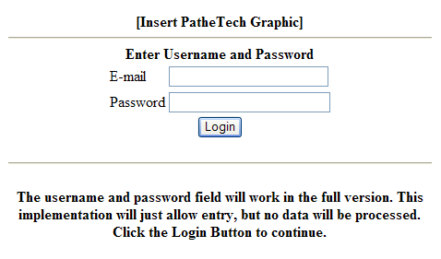
This page is constrained to the following format:
      - The logo is the website is listed first. This image will improve the appearance of the website.
      - The login portion is listed second. This portion will allow the mechanic to enter the login data and proceed to the mechanic menu.

2. Mechanic Menu
This page provides the basic choices for the mechanic. It summarizes all actions the mechanic can take.
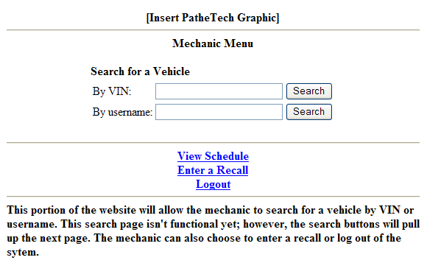 The mechanic has several options described below.
      - Vehicle search: The mechanic will be capable of searching for a vehicle by VIN or owner’s username. A search by VIN will proceed to the vehicle options menu while a username search will proceed to the username options menu.
      - View schedule: The mechanic can view the daily schedule for the garage.
      - Enter a recall: The mechanic can enter a recall which will send out a preformatted email to customers who own the vehicle.
      - Logout: The mechanic can logout of the system.
- Mechanic Username Options Menu
This page is the result of a username search. It will supply several options for the mechanic based on a given users information
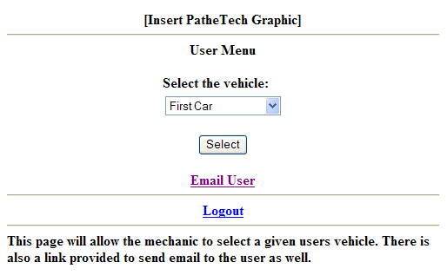
The mechanic has the following choices:
      - Select a specific user’s vehicle.
      - Send email to the user.
      - Logout
- Mechanic Vehicle Options Menu
This menu will provide the mechanic with the basic actions he can perform based on a given vehicle
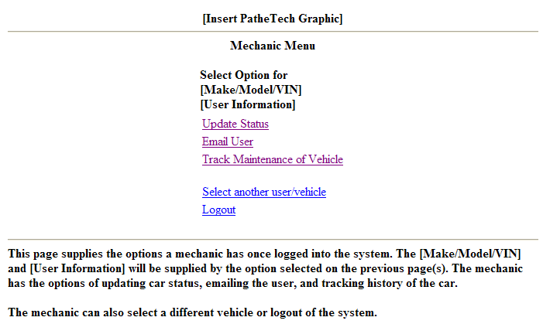
The mechanic has the options to:
      - Update Status
      - Email User
      - Track Maintenance of Vehicle
      - Select a new user/vehicle (links to mechanic menu)
      - Logout
- Email User Form
This page will allow the mechanic to send an email to the user with a web form.
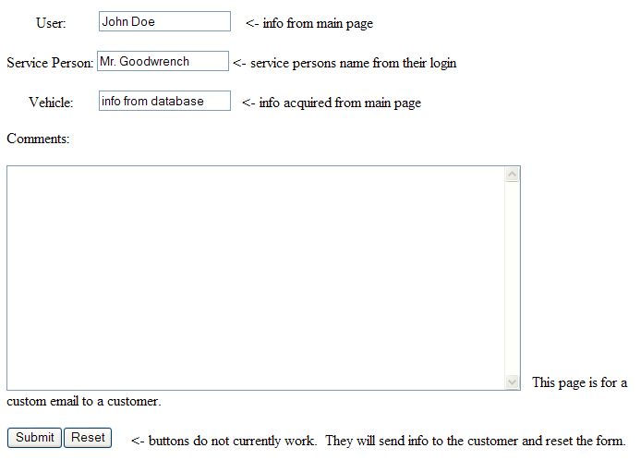
The mechanic will only need to fill in his name and the email content. The users name and vehicle information will be retrieved from the database prior to the execution of the page.
- Vehicle Update Form
This webpage will allow the mechanic to update the status of the vehicle. Repair services, costs, and messages will be posted on this screen.
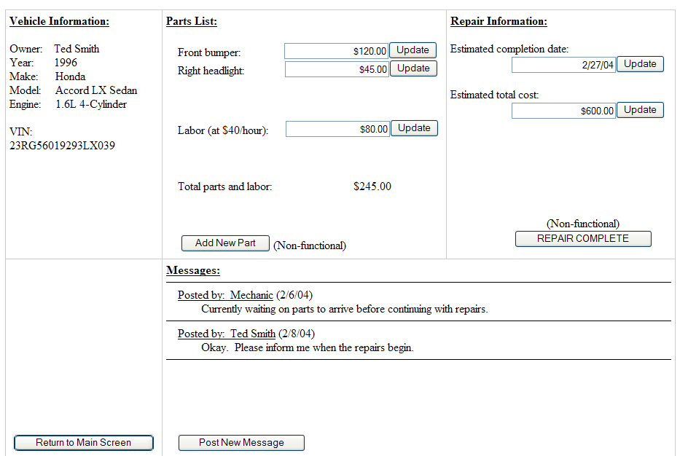
The major portions of this form are as follows:
      - Vehicle information: All vehicle information stored in the database will be displayed in this portion.
      - The Parts List: The parts list will allow the mechanic to add parts, and update parts and labor costs. Total parts cost will be listed in this section as well.
      - Repair Information: The estimated completion date and estimated total cost can be posted and updated by the mechanic.
      - Messages: The mechanic will have the capability to enter messages for the user to view. The post message button will bring up past message page which will have a text box and submit button.
      - The return to main screen button will take the mechanic back to the vehicle options page.
7. Vehicle Recall Form
The vehicle recall page will allow the mechanic to enter recall data for a specific type of vehicle. Once the information is submitted, an email will be sent from the server informing all owners of the given vehicle type of the recall.
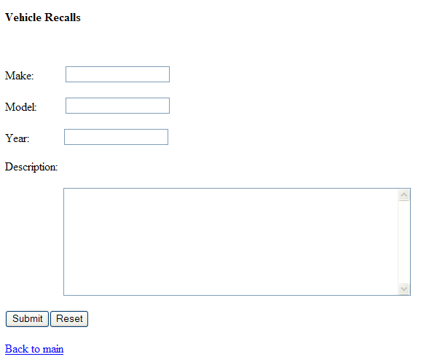
The mechanic must supply the following information before submitting the recall:
      - Vehicle Make
      - Vehicle Model
      - Vehicle Year
      - Recall Description
8. Maintenance Schedule Form
This page will allow the mechanic to view the upcoming maintenance for any given vehicle. It will be divided into two main sections. The first section defines upcoming maintenance which is scheduled. The second section will provide the mechanic with the overdue required maintenance.
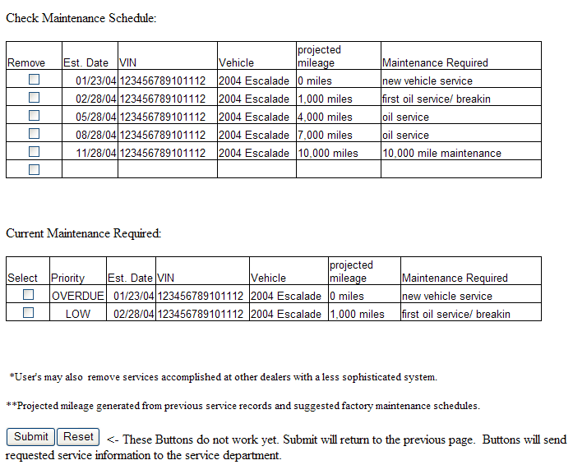

- Customer Pages
1. Login Page
This is the first page the customers will need to enter. This page will allow the customer to log in to the website.
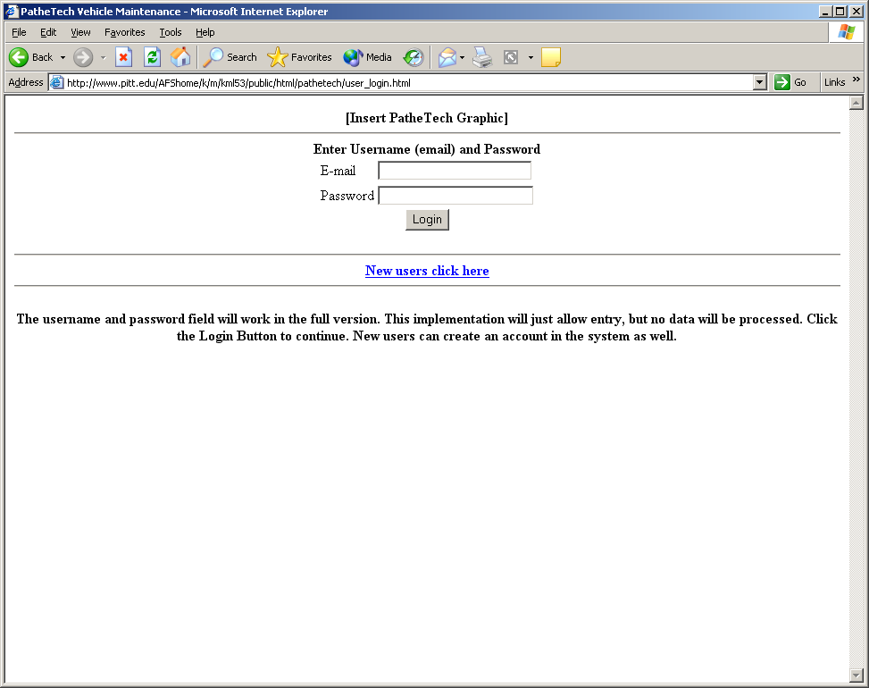
This page is constrained to the following format:
      - The logo is shown at the top of the page. This image will improve the appearance of the website.
      - The login portion is listed second. This portion will allow the customer to enter the login data.
      - Below this, there is a link for new customers to create an account.
2. Create New Account Page
This is the page that new customers will need to enter in order to create their account.
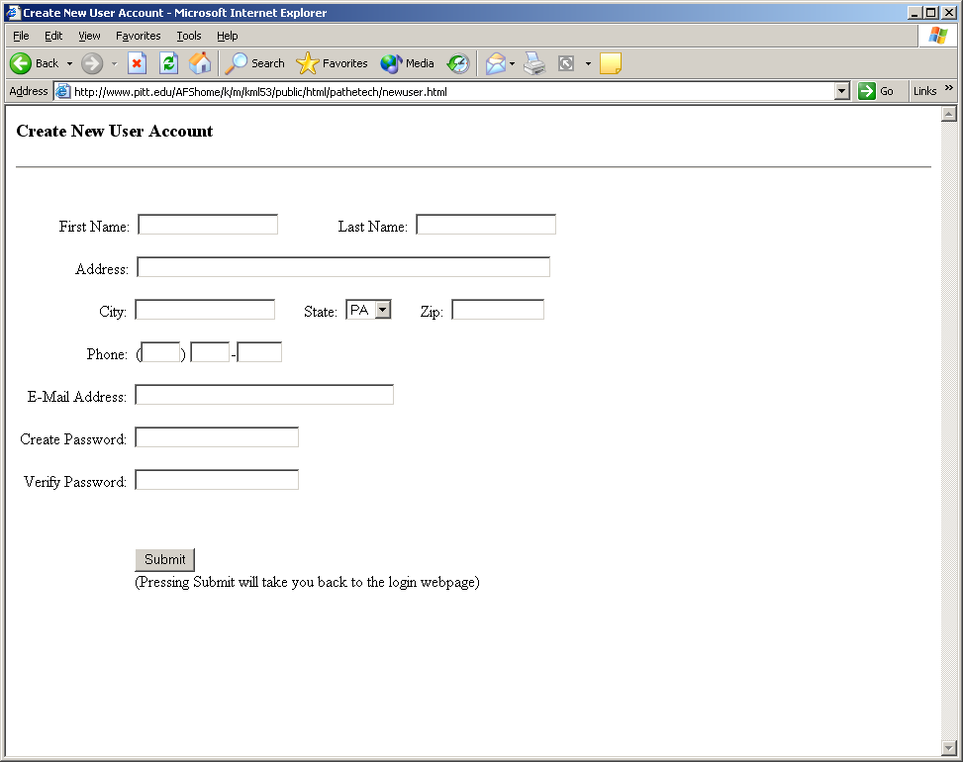
This page is constrained to the following format:
      - This page is simply one big form where all of the customer's information can be entered.
3. Main Customer Page
This page allows the customer to either enter the car they wish to check on, modify their account, or logout.
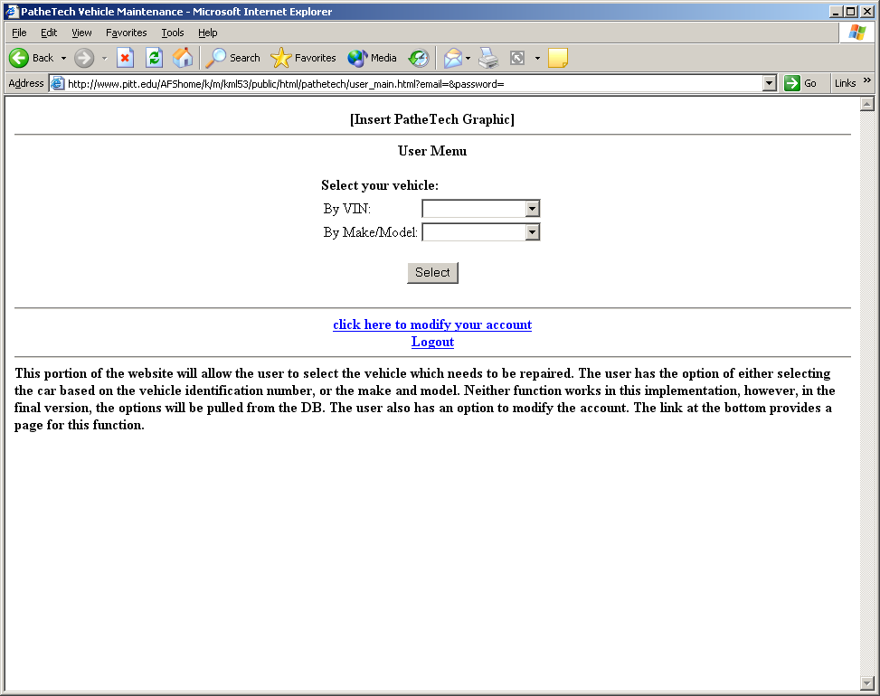
The customer has several options described below.
      - The customer can select the car they wish to check on either by the car's VIN, or the make and model from pull down boxes at the top of the page.
      - The customer can go to the modify account page.
      - The customer can logout of the system.
4. Modify Account Page
This page allows the customer to change any of their information, or add and remove cars.
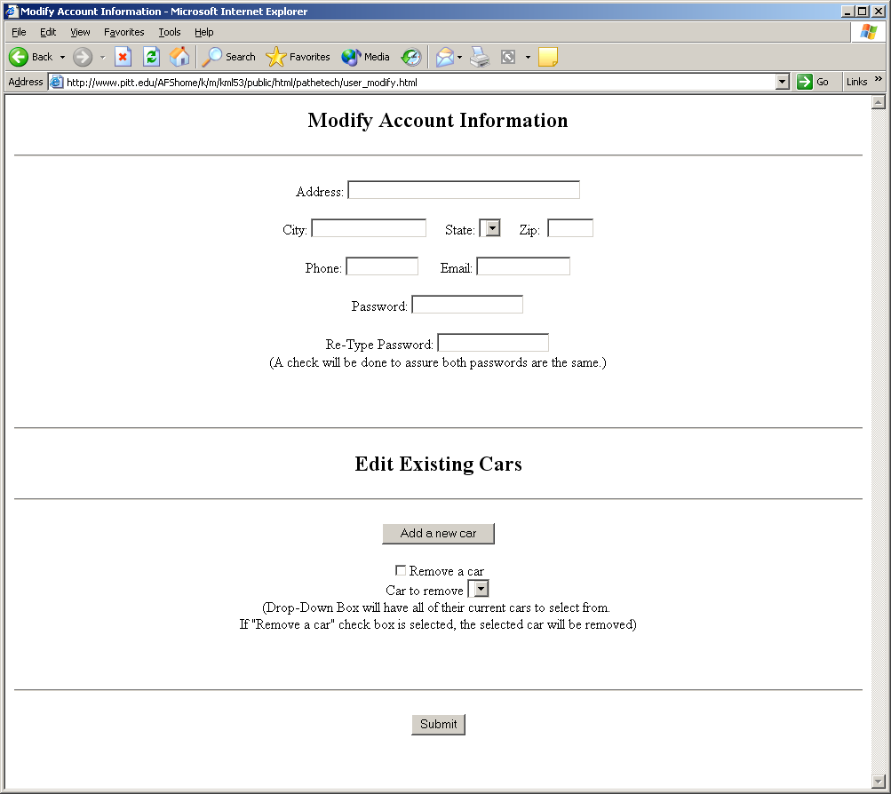
The customer has several options described below.
      - This page has a form at the top of it that resembles the create account page. Any of this information can be changed here.
      - Below this there is a link to the add car page, where a customer can add a new car to their account.
      - Below this there is a checkbox and a drop down box that where the user can select any of the cars on their account to be removed.
5. Add Car Page
This page allows the customer to add cars to their account.
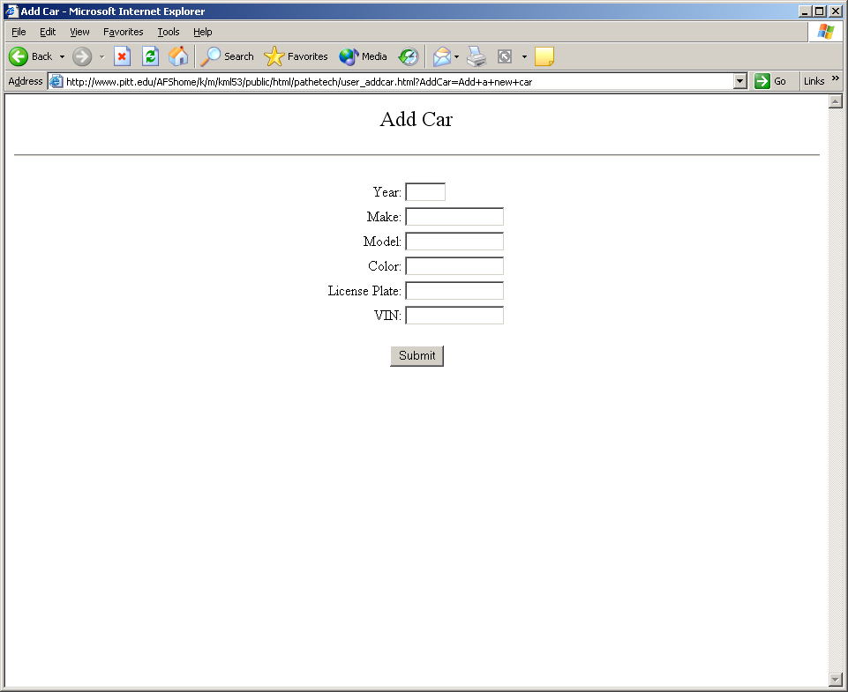
This page is constrained to the following format:
      - This page is just a simple form that allows the customer to enter all of the necessary information about a new car.
6. Customer Main Menu
This page is the main menu for the customer and will allow them to view any of the other information that has to do with the selected car.
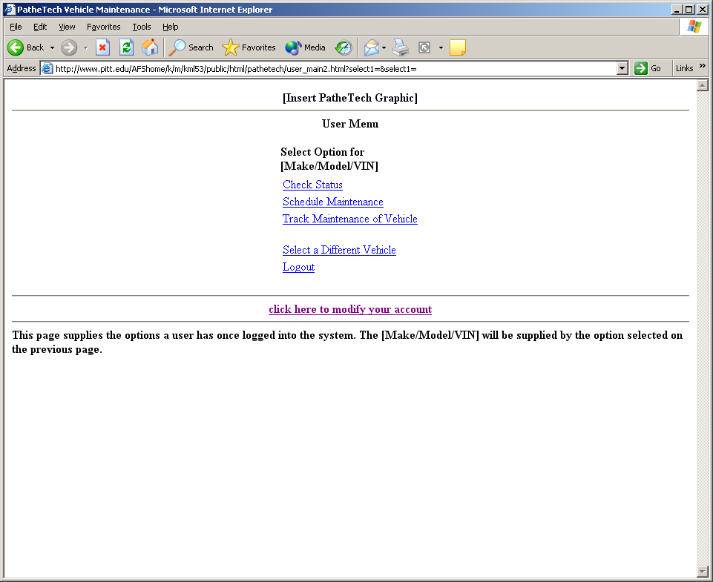
The customer has several options described below.
      - Check Status: The customer can check the status of repairs on their car from here.
      - Schedule Maintenance: The customer can schedule maintenance on their car here.
      - Track Maintenance of Vehicle: View all previous maintenance performed on car.
      - Select a Different Vehicle: This will take the customer back to the main customer page.
      - Logout
      - Modify your Account: This takes the customer back to the modify account page.
7. Customer Check Status Page
This page allows the customer to check on the current status of the car that is being worked on.
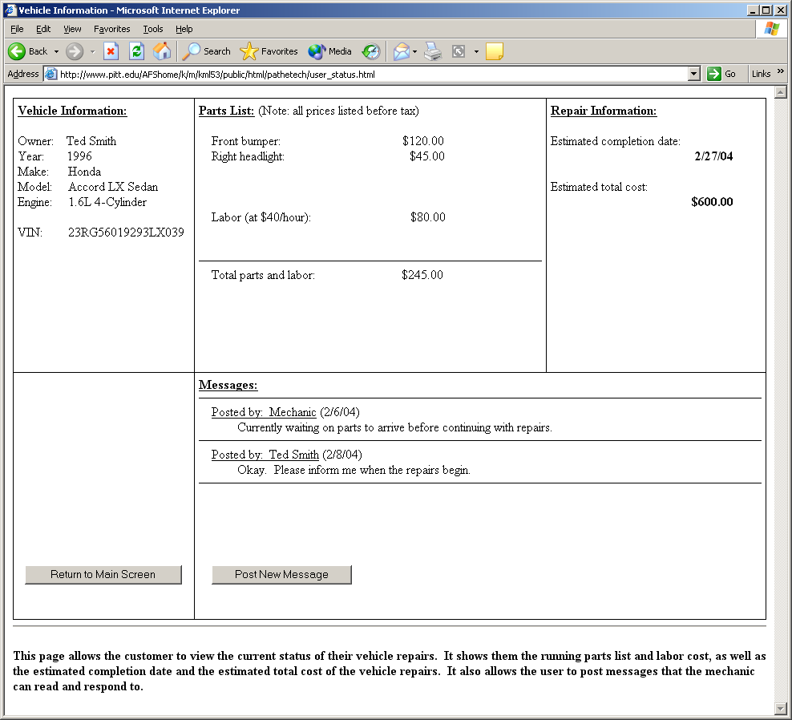
This page is constrained to the following format:
      - At the top left of the page, the customer's name, and vehicle information are displayed. Below this, there is a button to return to the main menu.
      - In the middle of the page, the parts needed and amount of labor are displayed along with the price of each. The total price is also listed here.
      - To the right of this, the date of repairs and total estimate are displayed.
      - Below this, there are messages that can be posted by the customer and mechanic. There is a button here to allow the customer to post a new message.
8. Schedule Maintenance Page
This page allows the customer to schedule new maintenance for the vehicle.
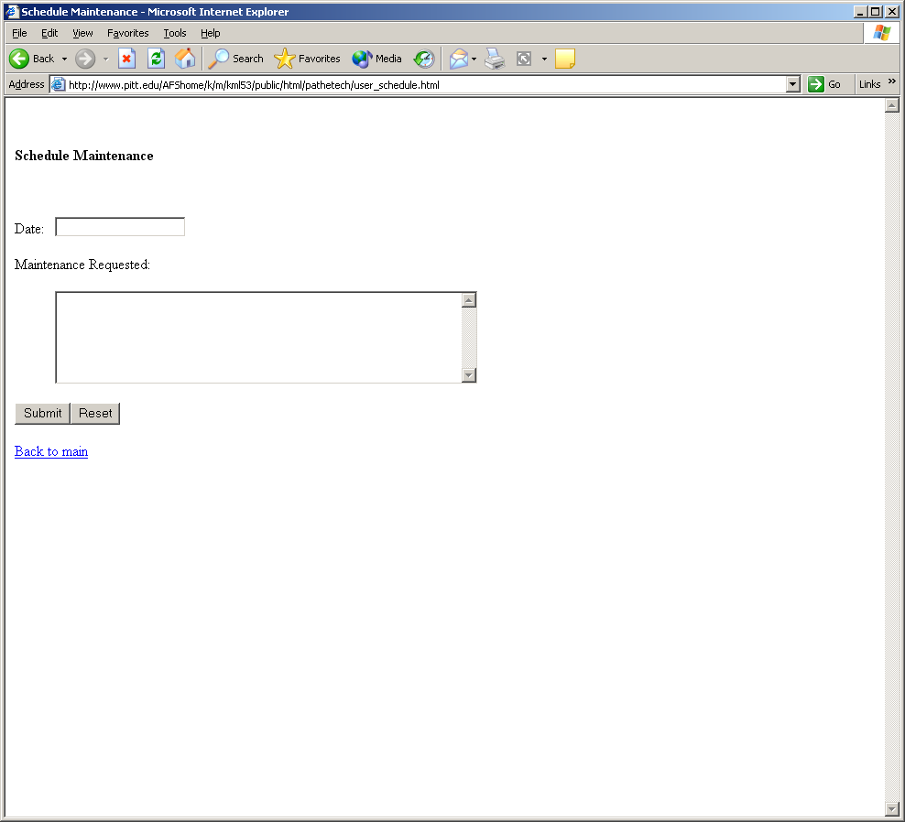
This page is constrained to the following format:
      - There is a text box at the top of the page where the date can be entered.
      - Below this there is a text field where a description can be typed of the maintenance that is needed.
9. Problem Tracker Page
This page allows the customer to view all of the previous maintenance that has been performed on this vehicle.
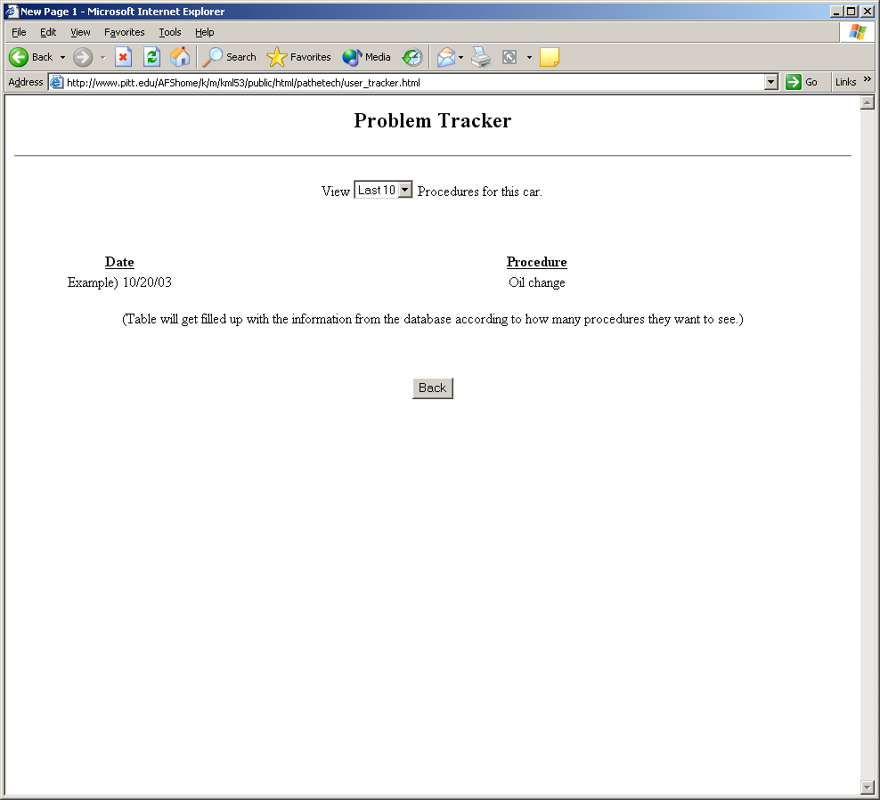
This page is constrained to the following format:
      - There is a drop down box at the top of the page where the amount of previous maintenance performed on the car can be selected.
      - Below this there will be a table that will display the previous maintenance on the car.

  - 4.1.2 CLI
No command line interface will be implemented.
  - 4.1.3 API
Application programming interface is not present.
  - 4.1.4 Diagnostics or ROM
The server status will output all information to a log file. Any errors and exceptions will be written to this file as well.
- 4.2 Hardware Interfaces

Using General Motors’ On-Star© wireless communication network, each car will be able to report breakdowns, engine faults, or other car problems automatically and remotely while within the On-Star© wireless coverage area. The server at the garage, connected to GM’s On-Star© network via the Internet, will be able to monitor any incoming error messages. These error messages will contain the vehicle’s unique sixteen character VIN number, and the nature of the vehicle’s problem. When the server receives an error code from a vehicle, it will automatically e-mail the customer with a notification that there is a problem with their vehicle. It will also post a message on the mechanic’s main login screen to the effect of “New On-Star© report for VIN: 0123456789ABCDEF”. It will provide a link to that vehicle’s main page, where the mechanic can view the nature of the problem. This will all be simulated in our program, with a separate simulation providing random fault data for the server to deal with.

- 4.3 Communication Interfaces
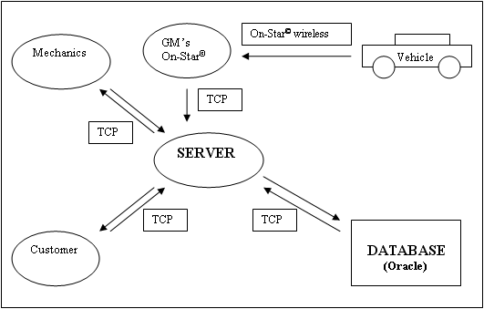
The server will support multiple threads to allow any number of users to access the database simultaneously. Each user will provide a username and password (which will be encrypted) to log on to the server. This will be checked with the database to see if there is a match. There will be one mechanic log in for every mechanic in the garage. Again, multiple threads will allow for multiple mechanics accessing the server at the same time. The server will also receive data from a central GM server which will provide fault data for GM vehicles relevant to that specific garage.

5. Use Cases and Operational Scenarios
• 5.1 User Creates an Account:
The new user creates an account, and adds contact and login information.
• 5.2 User Adds a new Vehicle
The user can add a new vehicle to their account, after entering the information the server saves it to the database.

• 5.3 Mechanic Updates Car Status
The mechanic can post updated information on the status of a repair including estimates on cost and time of completion. This information is saved to the database by the server.
• 5.4 User Checks Vehicle Status
The user can check the current status of the vehicle at any point in time during the repair process.
• 5.5 Mechanic Requesting Customer Confirmation
For some repairs, the mechanic may need to request user confirmation, such as for an expensive repair.
• 5.6 Mechanic Completes Repairs and Sends an E-Mail to notify the customer.
When the mechanic completes the repairs and updates the status, an e-mail is sent to the customer.

• 5.7 User Schedules Repairs
The user can check what times and dates are available, select a time, and give a description of the maintenance that needs to be done on the car.
• 5.8 Mechanic Enters Recall Information
The mechanic enters the car model and year affected by the recall, as well as comments which indicate the nature of the recall and provide other comments.
• 5.9 Server Notifies Customer of Needed Maintenance
The server can check if any cars are expected to need some form of regularly scheduled maintenance, such as an oil change, and send an e-mail to inform the customer.
• 5.10 Onboard System Informs Server of an Error
The onboard computer system can connect to the server to report a problem such as engine overheating.

6. Appendices
Specifies other useful information for understanding the requirements. All SRS documents should include at least the following two appendices:
- 6.1 Definitions, Acronyms, Abbreviations
V.I.N.: Vehicle Identification Number – unique sixteen character number used to identify a vehicle.

6.2 References

1) PatheTech Project Proposal
2) PatheTech Product Description
3) PatheTech Rapid Prototype
4) Meetings – Week of 1/7/04
5) Meetings – Week of 1/16/04
6) Meetings – Week of 1/23/04
7) Meetings – Week of 1/30/04
8) Meetings – Week of 2/05/04
9) Meetings – Week of 2/13/04
10) Meeting – 2/15/04

